2/27/2025

Riphah International University

Lab Number:03

coal

Name: Ayesha Tayyaba

Sap Id: 56546

Department: CS-4

TASKS

**Task: 01**

Write an assembly program to print a single character on screen.

Code:

;TO DISPALAY THR CHARACTER A

ORG 100H

.DATA

.CODE

MAIN PROC

MOV DL,'a'

MOV AH,2H

INT 21H

MAIN ENDP

END MAIN

**OUTPUT:**

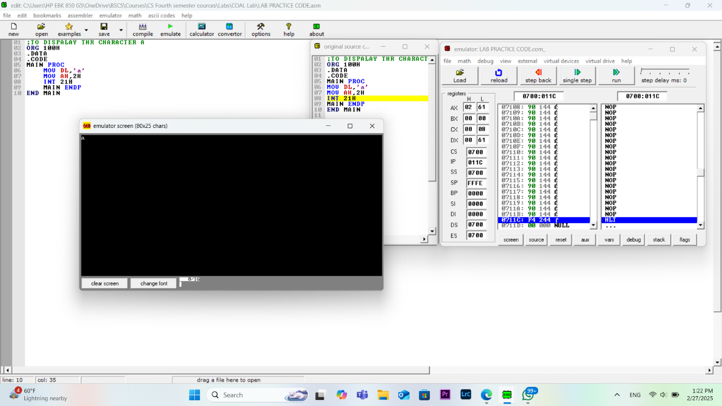

**Task 02:**

Write a program to print your name on screen with characters.

**Code:**

;To display name on screen with

ORG 100H

.DATA

.CODE

MAIN PROC

MOV DL,'A'

MOV AH,2H

INT 21H

MOV DL, 'Y'

MOV AH,2H

INT 21H

MOV DL, 'E'

MOV AH,2H

INT 21H

MOV DL, 'S'

MOV AH,2H

INT 21H

MOV DL, 'H'

MOV AH,2H

INT 21H

MOV DL, 'A'

MOV AH,2H

INT 21H

MAIN ENDP

END MAIN

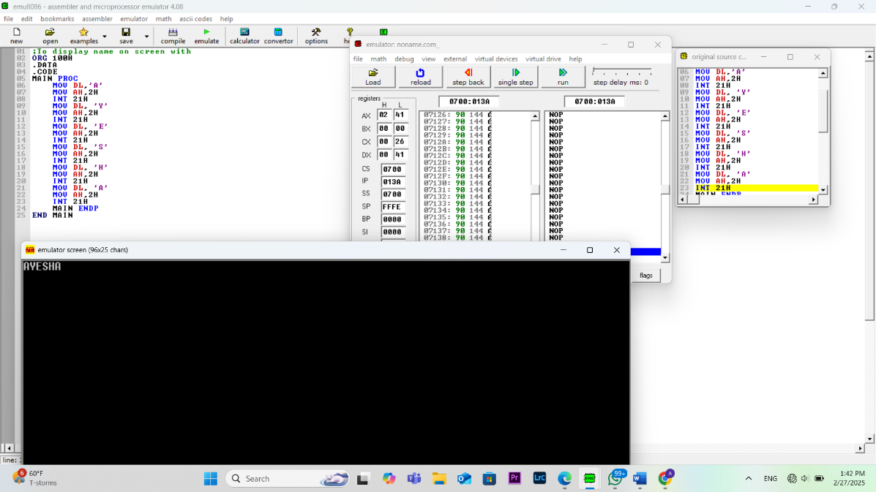**OUTPUT:**

**Task 03:**

;TWrite a program that input a character from user is in lowercase, the program will

;convert it to uppercase and will display it on console after conversion.

**Code:**

ORG 100H

.DATA

.CODE

MAIN PROC

MOV DL,'C'

MOV AH,2H

INT 21H

MOV DL, 'H'

MOV AH,2H

INT 21H

MOV DL, 'A'

MOV AH,2H

INT 21H

MOV DL, 'R'

MOV AH,2H

INT 21H

MOV DL, 'A'

MOV AH,2H

INT 21H

MOV DL, 'C'

MOV AH,2H

INT 21H

MOV DL, 'T'

MOV AH,2H

INT 21H

MOV DL, 'E'

MOV AH,2H

INT 21H

MOV DL, 'R'

MOV AH,2H

INT 21H

MOV AH, 1H

INT 21H

CMP AL, 'a'

JB DISPLAY

CMP AL, 'z'

JA DISPLAY

SUB AL, 32

DISPLAY:

MOV DL, AL

MOV AH, 2H

INT 21H

MOV AH, 4CH

INT 21H

MAIN ENDP

END MAIN

**OUTPUT:**

